1. **Given the provided data, what are three conclusion we can draw about Kickstarter campaigns?**

* The month of May has the highest number of successful launches and December has the lowest number of successful launches.
* Cancelled projects are consistently low compared to successful and failed projects.
* All campaign activity drops off in the last half of the year.

1. **What are some limitations of this dataset?**

This specific graph does not show the duration of the launch which may also have an effect on a successful campaign.

This would show how close to success the failed campaign actually was by using the percent funded data. Adding the country field into the data would also be helpful to see trend by country.

1. Another possible table to use would be one that ranks the outcome by country with category and sub-category as filters.

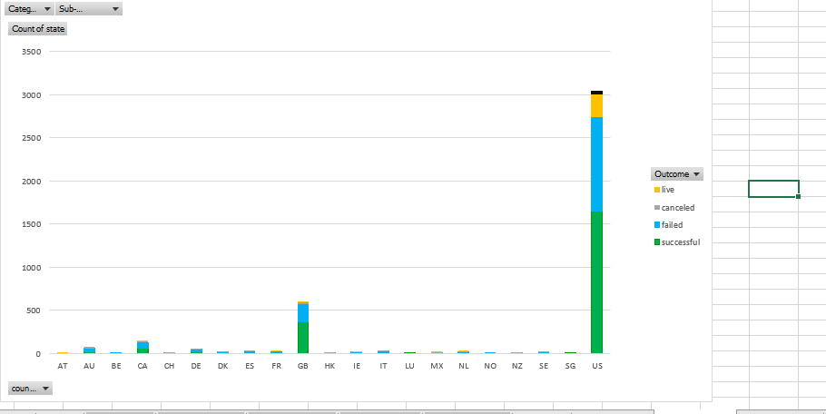

Or

The percentage funded compared to the campaign duration. I created groups of percentage funded and also for duration then charted the graph showing campaigns with a 31-60 day duration had the highest number of fully funded campaigns

